**AWS Business Professional – Module 1: AWS Introduction and Cloud Computing**

# Module 1: AWS and Cloud Computing

## Definitions

### Cloud Computing is the on – demand delivery of IT resources and applications via the Internet, with pay – as – you – pricing.

### A region is a collection of 2 more Availability Zones in a specific geographic area so instances run, databases initiated, etc.

### An AZ, or Availability Zone, is an isolated collection of AWS resources similar to clusters in data centers.

### Edge Location is a robust content delivery network for dynamic, static and streaming content for faster content delivery such as an entire website.

### Fault tolerance is the property that enables a system to continue operating properly in the event of the failure of some (one or more faults within) of its components.

### AWS Global Infrastructure are Regions, AZ and Edge Locations

## Advantages

### Instead buying, owning and maintaining your company’s data centers and servers, organizations can acquire compute power, storage, databases and other services as a needed basis like electricity in your home.

### Businesses only pay what they use as capacity may grow or shrink

### Agility

#### Speed

##### AWS has invested in facilities around the world so you and your company do not have to invest in an overseas datacenter

#### Experimentation

##### Reduce the time to get resources available to just minutes

##### Lower cost and time to experiment and develop

##### Increase agility for your organization

#### Culture of Innovation

##### Lower cost innovation motivates versus over caution alternative

##### Open to speculative ideas, quickly and cheaply so more chances

### AZ’s optimize latency (i.e. low latency connectivity), minimize costs and protect your application from a possible failure (i.e. launch instances in separate AZ’s)

## Requirements

### Large amount of services with a lot of features for each service

### Very large geographical footprint

### Redundant global computing infrastructure in several regions

### New services and new features are introduced regularly, either automatically with the service or customers can decide

# Module 2: AWS Value Proposition and Services Positioning

## AWS Partner Ecosystem (APN) is a Global *partner* program for AWS technical, business, marketing, training and GTM support

## AWS Managed Service Program provides APN partners with technical and business benefits to deliver AWS Cloud services as business solutions to AWS Customers

## AWS Marketplace allows customers to discover, evaluate and purchase IT and business software optimized for the AWS Cloud . . . it is an online software store for customers to run on AWS

### Will be charged by hour, month or an annual subscription

### AWS Customers buy from ISV, Independent Service Vendors, VAR, Value Added Resellers and *SI*, System Integrators

### Advantages

#### Customers

##### Hourly, monthly or an annual subscription

##### Pay as you go with no long term commitment

##### On – Board products to the cloud in days

##### Breadth of available products optimized for AWS

#### Seller

##### Access to thousands of AWS Customers

##### Reduce sales cycles from months to weeks, days

##### AWS does a lot the work as seller provides software bits and a rate sheet

##### Tools to manage and grow

#### Consulting, SI

##### AWS does a lot the work as seller provides software bits and a rate sheet

##### Chance to upsell of services

##### Access a global sales channel

##### Ease of procurement and deployment

## Core Benefits

### Cost

#### Alternative to AWS Cloud is on premises physical space, cabling, cooling, power, network, physical racks, servers, storage, certification and labor

##### Cloud is an up running in minutes without upfront expense and no long term commitments with continuously lowering prices

### Elasticity

#### Estimations of demand may underestimate resources causing underpay and overestimation wasting money, but cloud has little estimation of demand to match actual demand with a reasonable budget

#### Only pay for resources used on AWS cloud as the usage and traffic is mapped

### Flexibility

#### Use Cases of AWS

##### Web, mobile and business applications, Big Data high performance computing (HPC), backup, archive and disaster recover

### Security

#### Small companies benefits as they may not afford security

#### Share responsibility Model reduced security surface area

#### Responsibility of the Customer

##### Configuration and management operating system, applications, security groups, firewalls, network configuration and acct mgmt.

#### Constantly evolving security certifications universe

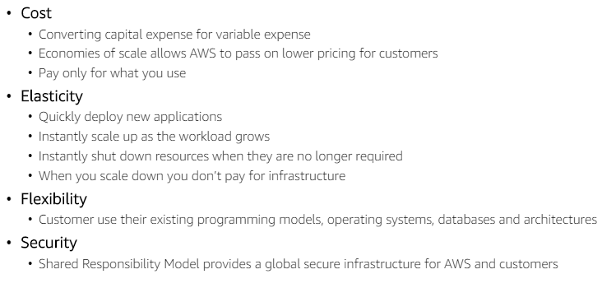

## Cloud Computing Journey

### Explore (First Specialist Phase)

#### Deploy non – critical applications

#### Set up security and user roles

#### Configure VPC

#### Integrate with AWS Environment

#### Deploy dev / test workloads

### Adopt (Second Specialist Phase)

#### Company website moved to AWS

#### Run test / dev applications

#### Migrate production applications

#### Deploy analytic workloads

### Expand (First Transformers Phase)

#### Expand their use of the AWS platform

#### View the platform from a whole business perspective

#### Form teams to explore area to leverage

### Transform (Second Transformers Phase)

#### Companies revisit and align their core IT strategies with the cloud

#### Adopt DevOps methodologies

#### Focus on automation and code refactoring to leverage AWS application services

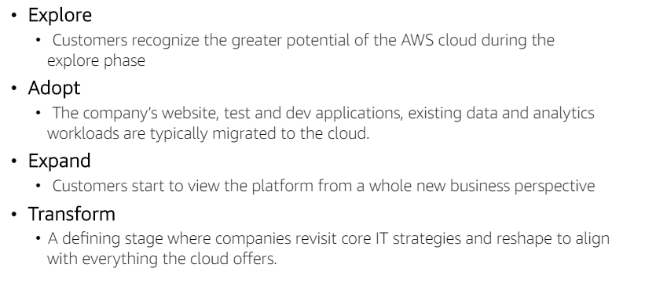

# Module 3: AWS Total Cost of Ownership and Pricing

## Total Cost of Ownership (TCO)

### Evaluation Methodology

#### Acquisition

#### Operating costs, decommissioning and retiring systems

#### Finance Metrics

#### Estimate / Compare direct and indirect costs

#### Opportunity costs

##### Frees up time to focus on your business

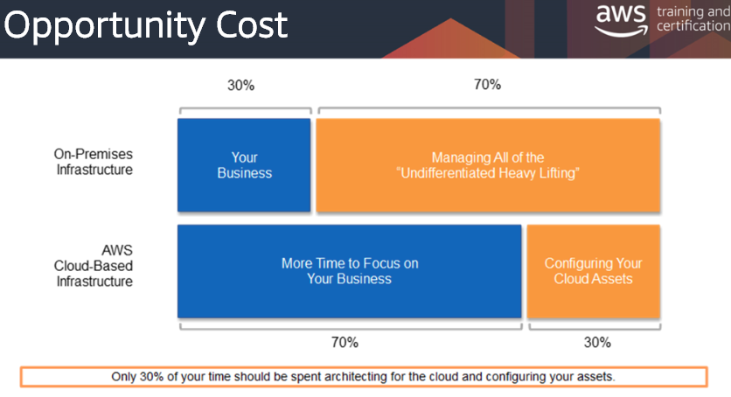

### Difficult to have apples to apples cost comparison between AWS Cloud and on – premises, but there is online TCO calculator

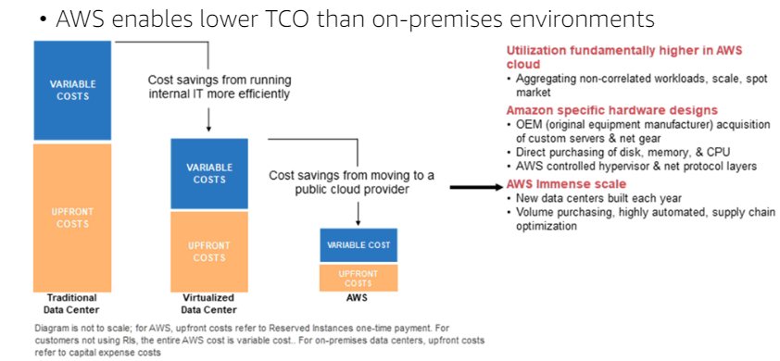

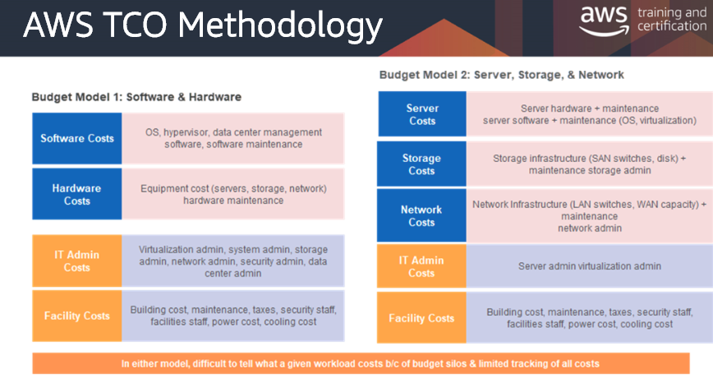

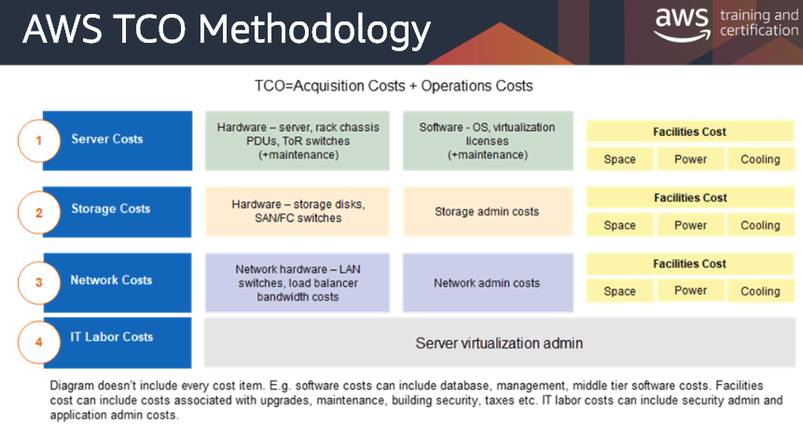

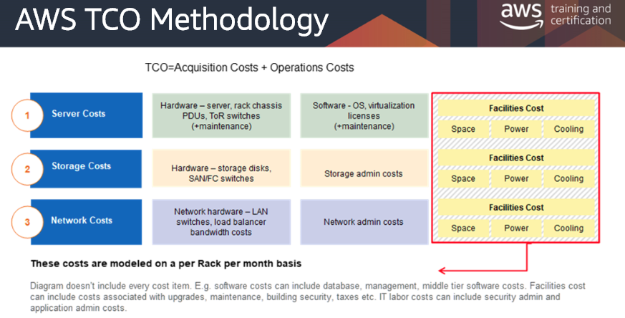

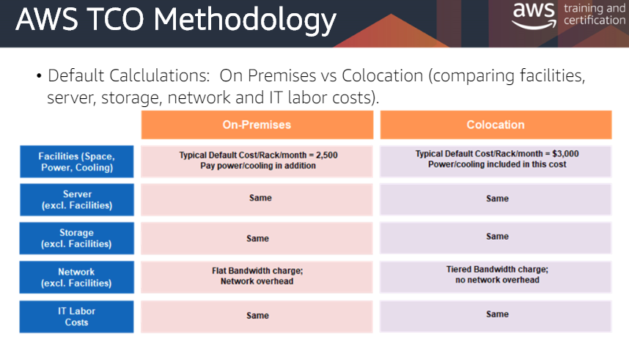

## Replace large upfront expenditures with pay as you go

## Pricing model choice to support variable and stable workloads

## Save more money as you grow bigger

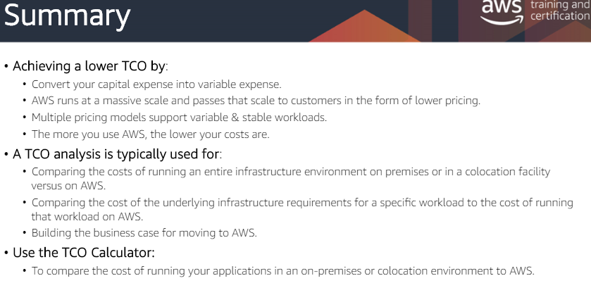

## AWS Pricing Principles

### No upfront investment, pay per use, pay as you go, serviced priced independently, volume pricing discounts and reserved instance discounts

## Economies of Scale

### AWS takes massive scale and passes that onto customers with continued growth of AWS customer base and increased investments in infrastructure

## AWS Free Tier

### Pricing segment that is free for 12 months

## AWS Trusted Advisor

### Service that monitors AWS customer environment for cost savings, security, fault tolerance and performance

## Fundamental Cost Characteristics

### Compute, Storage and Data Transfer Out

## Amazon EC2 Pricing

### Compute

#### Instance type / hour

#### Amazon EC2 purchase

#### Network I / O

### Storage

#### Volume Storage

#### Snapshot storage

##### EBS Snapshot saved to S3

###### S3 provides simple web services interface to store and retrieve any amount of data

#### Volume I / O

### Other Costs

#### Load balancing

#### Detailed Monitoring

#### Auto Scaling

#### Elastic IP Addresses

#### Operating Systems and Software Packages

#### Data Transfer Costs

##### Amazon Relational Database Service (Amazon RDS) makes it easy to set up, operate, and scale a relational database in the cloud.

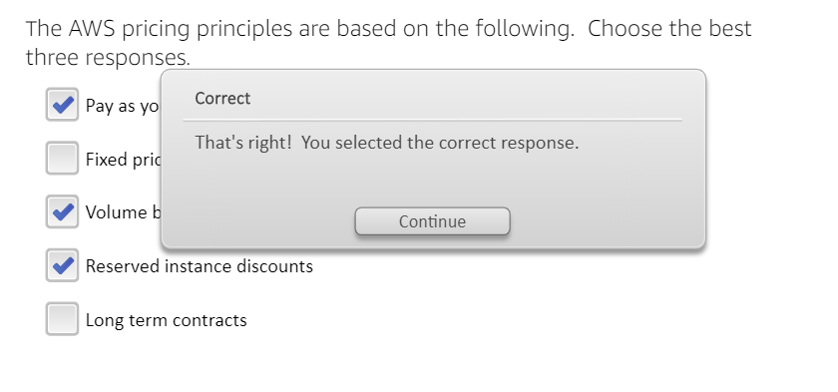

# Module 4: AWS Products and Services Overview

## AWS products and services are available on – demand through a web based management console or programmatically through a robust API

### Amazon Elastic Compute Cloud (EC2),

#### Virtual Computing Environments or instances

#### Amazon Machine Image (AMI)

##### Pre – configured templates for instances that package the bits for your server, including the operation system along with instance types

###### Instance Types provide a wide variety of CPU, Memory, Storage and networking capacity

Each one has a size and optimized for computation, memory, storage or general purpose instance type

#### Optimized for a variety of use cases to provide flexibility

### Auto Scaling

#### Automated up and down capacity of the Amazon EC2

### Elastic Load Balancing (ELB)

#### Automated traffic distribution across multiple EC2 instances

#### Enables high fault tolerance in applications

#### Dynamically grows and shrinks resources on traffic

#### Identifies and removes unhealthy instances

#### Seamlessly integrates with Auto Scaling to add or remove instances

#### Works with Amazon Private Cloud to provide robust network, security

### AWS Lambda runs your backend code in response to events and automatically manages compute resources

#### Compute service

### AWS EC2 Container Service (ECS)

#### Run applications on a managed cluster of Amazon EC2 instances

#### Definitions

##### Container Service is a standardized method to package your application's code, configurations, and dependencies into a single object that share an operating system installed on the server and run as resource-isolated processes for quick, reliable, and consistent deployments, regardless of environment

##### Docker is a software platform that allows you to build, test, and deploy applications quickly.

#### ECS is OCI Compliant and can include docker containers

### Advantages

#### Elastic Scale capacity as compute requirement change

#### Flexible Resizable compute capacity

#### Secure Configure security and network access

#### Low Cost Pay only for used capacity, not unused

### Amazon EC2 Cost Model

#### On – Demand

##### Pay by capacity by the hour with no long term commitments

#### Reserved

##### Pay upfront to lower hourly prices rather than on – demand

#### Spot

##### Bid for unused Amazon EC2 capacity where prices are set by Amazon EC2 depending on supply and demand of spot instances

#### Dedicated

##### Launch instances on dedicated customer hardware on a private isolated network where you pay for only for what you use

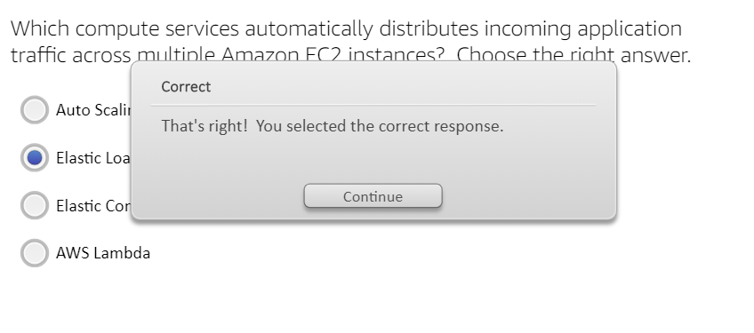

## Storage

### Storage Services

#### Amazon S3 (Simple Storage Service) Object Store

##### Durable, scalable object storage service (Storage for internet)

##### Store and retrieve any amount of data from anywhere

##### Static images and video files

##### High latency so long delays and cannot modify files

##### Store buckets in one of several AWS Regions

##### Best for website with a lot static images & videos with no need to modify, but does require unlimited additions, deletions to load *quickly*

#### Amazon EBS (Elastic Block Store)

##### Block Storage with Amazon EC2

##### Like a hard drive with an operation system

###### Create partitions on it, format it, boot your OS off it

##### Can be modified and automatically replicated in AZ to protect from component failure resulting in higher availability and durability

##### Best for website with a lot images and videos because of the OS

#### Amazon Glacier

##### Archiving and backup for Amazon S3

##### Optimized infrequent data retrieval

##### Archives in multiple device facilities

##### Replaces physical media for archiving data with long retention periods, which has low durability, long recovery times and expensive

##### Average annual durability of 99.99999999999%

##### Add *any* amount of data, quickly, easily expire and delete

##### One penny per gigabyte per month

#### AWS Storage Gateway

##### Integrates on – premises IT and AWS Cloud Storage

##### Cost effective backup and rapid disaster recovery

#### AWS Snowball (Physical Appliance)

##### Secure appliance to transport large amounts of data into and out of the AWS cloud on a petabyte scale

###### Fast, very scalable, tamper resistant, secure, low cost

###### Can be one fifth the cost of the internet

#### AWS CloudFront

##### Global content delivery network that caches content at edge locations to be closer to users around the world, low latency and fast

##### 

#### Amazon Elastic File System (EFS)

##### Create, configure file systems for EC2 instances

### Advantages

#### Low Cost

##### Pay only the storage & performance that you actually provision

#### Elastic

##### Scale capacity as computing requirement change

##### Unlimited number of objects to store

#### Flexible

##### Ability to choose volume types

###### Standard Volumes

I/O performance consistency is not critical

###### Provisioned IOPS volumes

I/O intensive workloads such as database

Consistent storage and low latency performance

IOPS is Input/Output Operations Per Second, a common performance measurement used to benchmark computer storage devices like hard disk drives (HDD), solid state drives (SSD), storage area networks (SAN).

##### Volume types differ in price and performance characteristics

#### Secure

##### Seamlessly encrypt EBS data volumes and snapshots

##### Configure S3 bucket policies to manage permissions

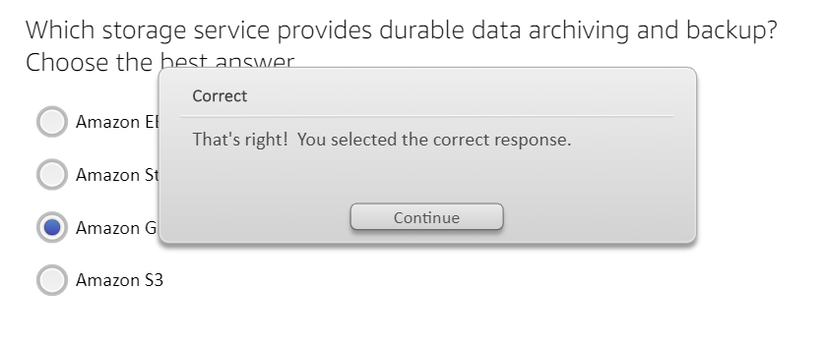

## Database

### Relational Databases (RDS)

#### MYSQL, Postgres, Oracle, SQL Server, Amazon Aurora

#### Cost efficient because customers only pay for what they use

#### Resizable capacity, automates time consuming tasks

#### No additional charge to use Amazon Cloudwatch metrics

### Non – Relational Databases

#### Amazon DynamoDB and Amazon ElastiCache

##### Amazon DynamoDB

###### NoSql database service

###### Store an unlimited amount of data

###### Provision and change the request capacity needed for each table with consistent low latency

###### Fast, predictable performance using SSD (Solid State Drives)

##### Amazon ElastiCache

###### In-memory caching service in the cloud rather

###### Improves application performance

###### Better than slower disk – based databases

###### Protocol – compliant with Memcached, a widely adopted memory object caching system that is on – demand

###### Simple API calls to grow, shrink cache cluster

### Advantages

#### Low Cost

#### Managed

##### Automate tasks like backups, patches, replication, etc.

#### Flexible

##### Choice of SQL, MySQL, Oracle or Postgres

#### Secure

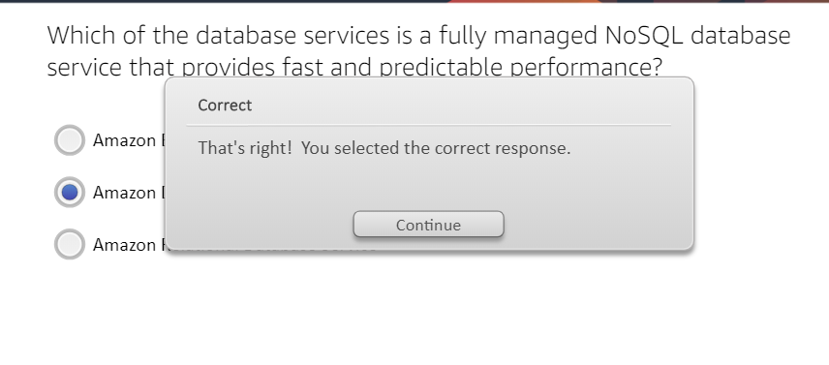

## Networking

### Amazon VPC (Virtual Private Cloud)

#### Customers provision isolated network section for deployment

#### VPN or physical data centers are required

#### Attach Amazon Elastic IP address to any instance in your VPC

#### Control in / outbound access to subnets using network access control lists

#### Create public and private subnets

#### Bridge your Amazon VPC and your onsite IT infrastructure

### AWS Direct Connect

#### Private connectivity btwn AWS and your data center that is standard 1 or 10 GB Ethernet fiber optic cable from your router to AWS Direct Connect router

#### Establish a network connection from on – premises to AWS

### Amazon Route 53

#### Domain Name System (DNS) web service, highly scalable that routes end users to Internet applications

##### Translates human readable names into numeric IP addresses

###### www.example.com to an IP address

#### Allows you to create and manage public DNS records w/low latency

### Advantages

#### Low Cost

##### No additional cost to secure your AWS resources

#### Elastic

##### Route 53 automatically scales to very large query volumes

#### Flexible

##### AWS console has a single view to manage your connections

#### Secure

##### Network access control lists control in and outbound access

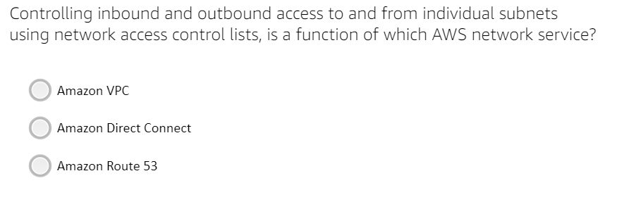

Amazon VPC is the correct answer

## Cloud Security, Identity and Compliance

### AWS IAM (Identity and Access Mgmt)

#### Manage users, groups and permissions, plus strong passwords

### AWS Directory Service

#### Connect existing on – premise Microsoft Directory or standalone

### AWS CloudHSM (Hardware Security Module)

#### Control encryption keys and cryptographic operations

### Amazon CloudWatch

#### Monitor resources, application monitoring, CPU metrics

### AWS CloudTrail

#### Records AWS API calls and delivers log files with event history

#### AWS account management for governance, compliance, auditing and risk

### AWS Config

#### Resource inventory configuration history

#### Investigate historical changes

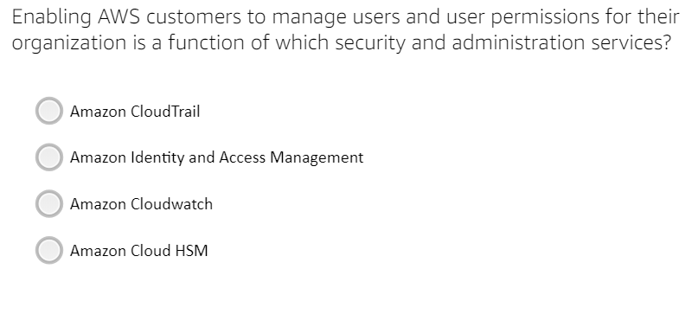

AWS IAM is the correct answer

## Analytics

### Amazon Redshift

#### Data warehouse that is petabyte scale up to 10x higher performance

#### Much cheaper than on – premises

### Amazon Elastic MapReduce (Amazon EMR)

#### Cost effective, scalable, large data processer across EC2 instances

#### Primarily use Hadoop framework, but can also use other popular distributed frameworks like Apache Spark, HBase, Presto and Flink in EMR

#### Broad set of big data use cases

##### Log analysis, web indexing, ETL, machine learning, financial analysis, simulation and bioinformatics

### Amazon Kinesis

#### Real – time distributed data stream processing at a massive scale

#### Automatically manages infrastructure, storage, config and networking

### Amazon Athena

#### Fast interactive query service of Amazon S3 using standard SQL

#### Serverless so no infrastructure to manage

#### Pay only for the queries you run

#### No need for complex ETL jobs to prepare data for analysis

### Amazon QuickSight

#### Dashboard, cloud powered BI service for visualizations

#### Pay per session pricing cost effectiveness with no upfront costs, no annual commitments and no charges for inactive users

## Management Tools

### AWS CloudFormation

#### Simple text file to manage infrastructure resources

### AWS Auto Scaling

#### Scaling dashboard tracks and validates utilization

#### Can combine with Amazon EC2 Auto Scaling to scale additional AWS

### AWS Service Catalog

#### Catalog IT Services like VM, servers, software, databases, etc.

### AWS CloudWatch (In this Module in Roman numeral I)

#### Monitor EC2, set alarms, customize metrics like CPU, application monitoring, automatically react to resource changes

### AWS Systems Manager

#### Unified UI for your AWS infrastructure to automate operational tasks

### AWS CloudTrail (In this Module in Roman numeral I)

#### Records AWS API calls and delivers log files

#### AWS account management for governance, compliance, auditing and risk

### AWS Config

#### Assess, audit and evaluate configurations of your AWS resources

### AWS Managed Services

#### Infrastructure manager that automates change requests, patch management, security, access, incident mgmt., backup services, etc.

### AWS Trusted Advisor (also in Module 3)

#### Service that monitors AWS customer environment for cost savings, security, fault tolerance and performance

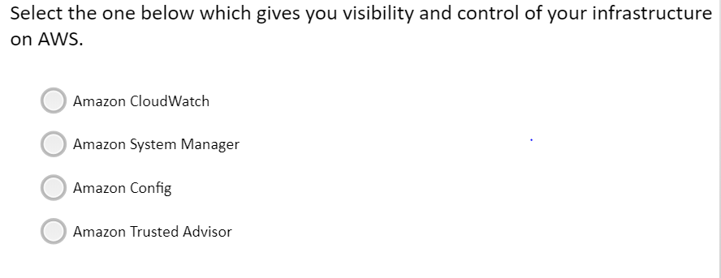

Amazon System Manager is the correct answer

## Mobiles Services

### Advantages

#### Start for free with no upfront cost and pay as you go

#### Add cloud services fast

#### Deliver quality apps

#### Engage your audience

### How it Works

#### Start your own app or use one of Amazon’s start up kits

#### AWS Mobile Hub to configure AWS services

##### Generate a cloud configuration file and store it

#### AWS Mobile SDK

##### Access to a range of AWS services

### Amazon API Gateway

#### No minimum fees or startup costs

#### Create, publish, maintain, monitor secure API’s at any scale

#### Access Amazon EC2, Amazon Lambda or any web application

### AWS Device Farm

#### Test environment for iOS, Android and web applications for bugs and performance problems in automated testing or remote access

### Amazon Cognito

#### Authentication Manager for mobile and web service to sign up, sign in and control access of users

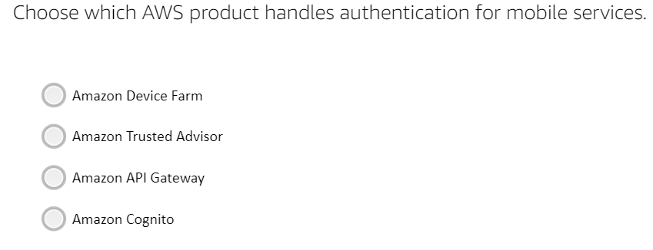

Amazon Cognito is the correct answer

## IoT (Internet of Things)

### Definition

#### A system of ubiquitous devices connecting the physical world to the cloud

### AWS IoT Core

#### Input

##### Billions of devices publish and subscribe to messages

#### AWS IoT

##### MQTT (Message Queuing Telemetry Transport) protocol sends and receives messages with minimal code & less network requirements

#### Output

##### Enables devices to communicate with AWS and each other

### AWS Greengrass

#### Extension of AWS functionality to the IoT by allowing businesses to perform data collection and analysis closer to the origin

#### A developer writes AWS Lambda functions & deploy them for Greengrass.

### AWS FreeRTOS

#### An operating system for microcontrollers that makes edge devices

### AWS IoT 1 – Click

#### Ease of Amazon Lambda functions for a specific function

### AWS IoT Additional Services

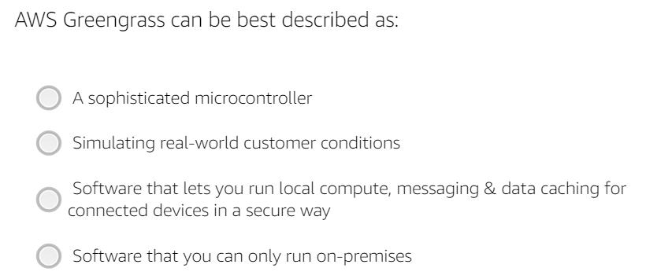

Software that lets you run local compute, message and data caching for connected devices in a secure way is the correct answer.

## Machine Learning

### Background

### AWS SageMaker

#### Build

##### Connect to other AWS services and transform data in SageMaker Notebooks

##### This is where you take the data or subset of data based on importance, exercise it to a set of models and then select the model

#### Train

##### Use SageMaker algorithms or bring your own for training

##### Training is using the selected data set and selected model by teaching predictions

#### Tune

#### Deploy

### AWS Comprehend

#### Definition

##### Natural Language Processing (NLP) service using machine learning to find insights and relationships in text

#### Input Phase

#### Comprehend Phase

##### Automatically extracts key phrases, sentiment, etc.

#### Output Phase

##### Extracted data with confidence scores

### AWS Lex

#### A service for building conversational interfaces into any application using voice and text, in terms of, deep learning as used in Alexa

#### Does have the advanced deep learning functionalities of automatic speech recognition (ASR) for converting speech to text and natural language understanding (NLU)

#### Automatically scales so no infrastructure worries

#### No upfront costs and you only pay for what you use

### AWS ML Additional Services

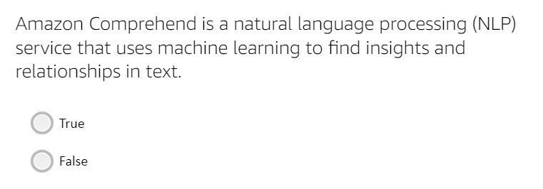

True

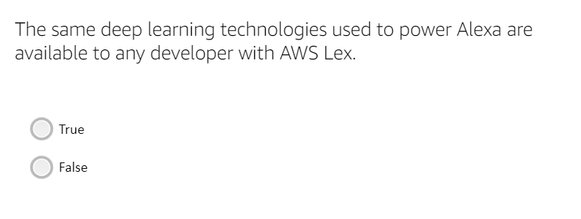

True

## Migration

### AWS Database Migration Service is the resource to move your on – premises data source or your open source data source to AWS

#### Also can stream data to Amazon Redshift, Amazon DynamoDB and S3

### AWS Server Migration Service

#### Agentless service that is free to use and you pay storage resources used during the migration process, plus incremental replication reduces server issues

### AWS Snowball (In this Module 4 under storage)

#### Secure appliance to transport large amounts of data into and out of the AWS cloud on a petabyte scale

##### Fast, very scalable, tamper resistant, secure, low cost

##### Can be one fifth the cost of the internet

#### First create a data transfer job in the AWS Management Console that was shipped to you, then connect to your network, download the client and identify data to transfer . . . so on

#### Can be one fifth the cost of high speed internet, no code purchase or hardware required, just have it shipped to you

### AWS Migration Hub

#### Aggregated migration service in a single location to progress check across multiple AWS, regardless of migration service types

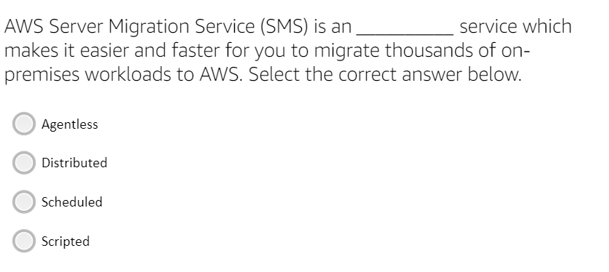

Agentless is the correct answer

# Module 5: AWS Solutions Part 1

## Web Site and Web Apps

### Refers to the collection of tools and technologies required to power internet applications.

### Case Study with Airbnb

#### Entire database migration to Amazon RDS with only 15 mins of downtime

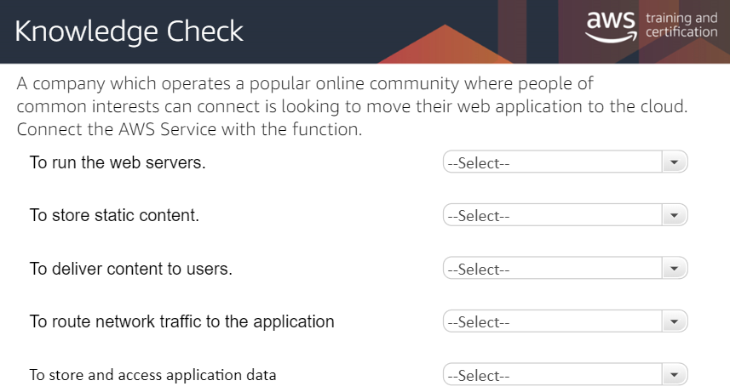

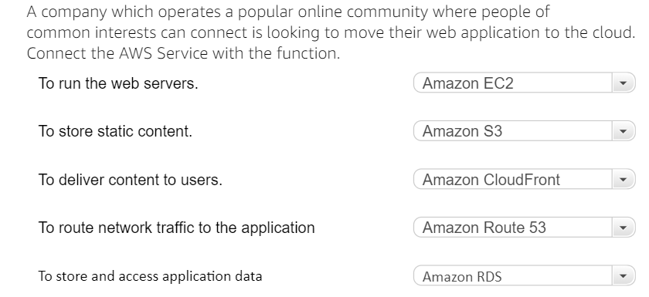

## Mobile Services

### Attributes

#### Scale automatically

#### Build apps not infrastructure

#### Push notifications to engage users

#### Integrated services

#### Backend you can customize

#### High performance and high availability

### Case Study – Easy Taxi

#### AWS adoption increased scale and reduced respond times

### AWS Marketplace Feature

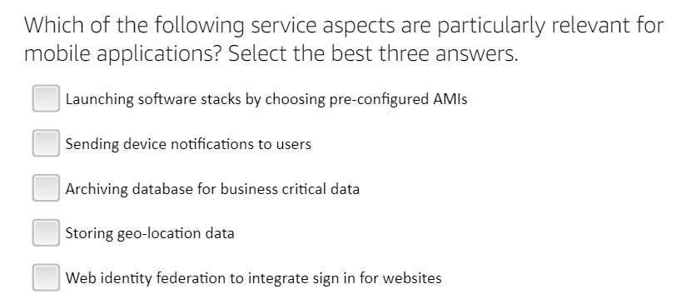

(2) Sending device notifications to users (4) Storing geo – location data and (5) Web identity federation to integrate sign in for website are the correct 3 answers

## Backup, Storage and Archive

### Advantages

#### Low Cost

##### Pay only for the data that is stored

#### Scalable

##### Unlimited storage scalability

#### Fast

#### Secure

## AWS Marketplace: Storage and Backup

### Disaster Recovery (DR)

#### Definition

##### Process to prepare for and recover from any negative impact event on the business from hardware, software, an outage or physical damage like a fire

#### AWS Advantages

##### Faster DR, less complex and lower cost

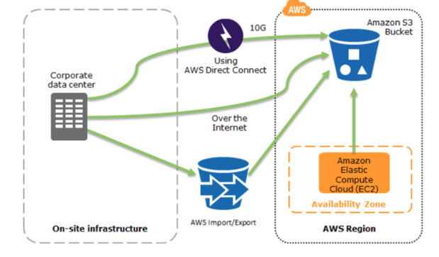

### Methods of DR

#### Many possible approaches, but 2 to look into

#### Pilot Light

##### Like a gas heater pilot light to indicate the heater is working

##### Requires entire infrastructure to be up and running in AWS

#### Warm Standby

##### Refers to a DR scenario of a scaled down version of a fully functional production environment is always running in the cloud

##### Extends the pilot light solution

##### Decreases recovery time because some services are still running

##### Servers running on minimum sized fleet of EC2 instances

##### Not scaled for full production and used for non – production like testing, QA and internal use

###### In a disaster, the system is scaled up quickly to handle the production load by adding more instances to the load balancer, (ELB), and by resizing the small capacity severs to run on larger Amazon EC2 instance types.

### In a production failure, the standby environment is scaled up for production, and DNS records are changed to route all traffic to AWS

### In general, horizontal scaling is preferred over vertical scaling

### Storage Competency Partners and Storage Competency Program are used to verify Storage and DR policies

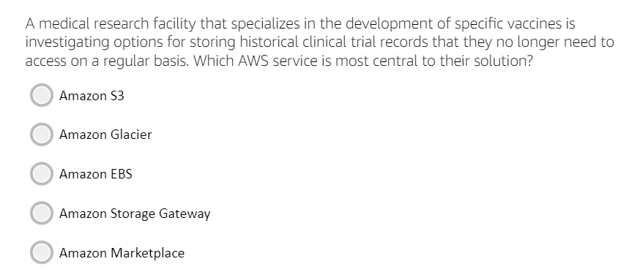

Amazon Glacier is the correct answer

## Big Data and High Performance

### Definition of Big Data

#### Data to big in size for traditional relational databases

### Big Data Tools

#### Amazon S3

##### To store static content (Simple Storage Service)

#### Amazon Kinesis

##### Real – time distributed data stream processing at a massive scale

##### Automated mgmt. of infrastructure, storage, config, networking

#### Amazon DynamoDB

#### Amazon Redshift

##### Data warehouse; petabyte scale up to 10x higher performance

#### Amazon Elastic MapReduce (EMR)

##### Cost effective, scalable, large dat

##### a processer across EC2 instances

##### Primarily use Hadoop framework, but can also use other popular distributed frameworks like Apache Spark, HBase, Presto, Flink in EMR

##### Broad set of big data use cases

###### Log analysis, web indexing, ETL, machine learning, financial analysis, simulation and bioinformatics

##### Collect and ingest data with Amazon Kinesis, store the data in Amazon S3, DynamoDB, Amazon RDS, Amazon Redshift and Amazon Glacier . . . process the data in Amazon EC2, EMR or Kinesis.

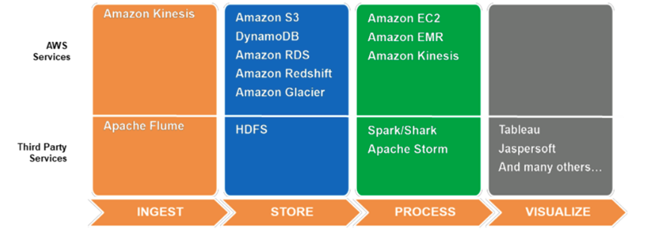

### Big Data Competency Partners and Big Data Competency Partners both are a resource for consulting on AWS

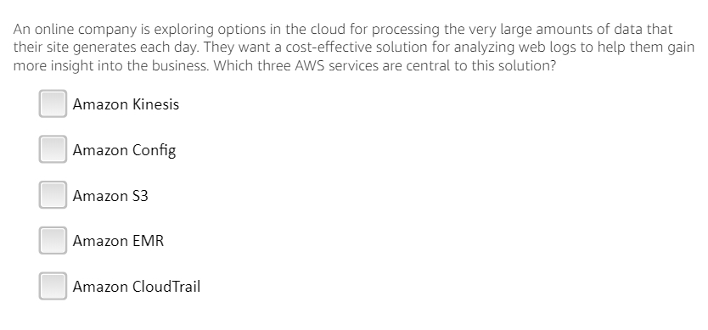

What are the 3 correct answers? Guessing to be Amazon EMR, Amazon Kinesis and ?

# Module 6: AWS Solutions Part 2

## Some Key Solutions

### Websites & Web Apps, Mobile Services, Backup, Storage and Archive, Big Data, Game Development, Business Applications and Productivity and Healthcare and Life sciences

## Game Development

### Low latency, competitive global matches, reduced player wait times and reduce cost up to 90%, scalability

## Business Applications and

### Customers can run their own applications or launch entire software stacks from Oracle, SAP, Microsoft and IBM on Amazon EC2 through pre – configured Amazon Machine Images (AMI)

### Configure and deploy windows applications with full, granular control

#### Microsoft SQL Server, SharePoint, Exchange Server and .NET

### For consultants, the Microsoft Competency Partner resource

### SAP on AWS

### Oracle on AWS

#### Scalable, secure, very available, simple deployment, efficient and lower TCO

#### For consultants, the Oracle Competency Partner

### AWS Business Productivity (Alexa)

### AWS Test Drive (Private Sandbox Test Environment)

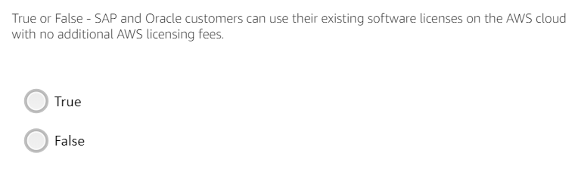

True is the correct answer

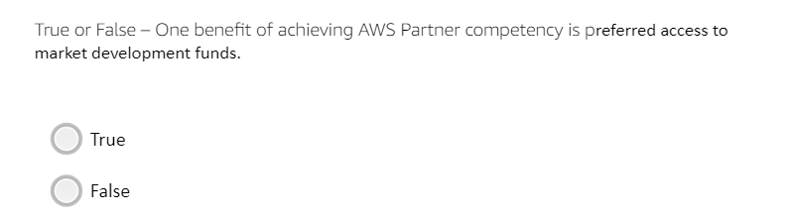

True is the correct answer

## Healthcare and Life Sciences

|  |  |  |
| --- | --- | --- |
| **Object, Component or Service** | **Module** | **Description** |
| Athena | 4 | Cloud Powered Business Interface (BI) |
| Availability Zone (AZ) | 1 | Isolated collection of AWS resources |
|  |  |  |
| Amazon CloudFront |  | To deliver content to users |
| Amazon EC2 | 4 | To run the web servers (Elastic Compute Cloud) |
|  |  |  |
|  |  |  |
|  |  |  |
| Region | 4 | A collection of 2 or more AZ in a specific geographic area so instances run, databases initiated, etc. |
|  |  |  |
| Amazon RDS | 4 | To store and access application data (Relational Database Service) |
| Amazon Route 53 | 4 | To route network traffic to the application |
| Amazon S3 | 4 | To store static content (Simple Storage Service) |
|  |  |  |
| Amazon Trusted Advisor | 3, 4 | Monitors AWS customer environment for cost savings, security, fault tolerance and performance |